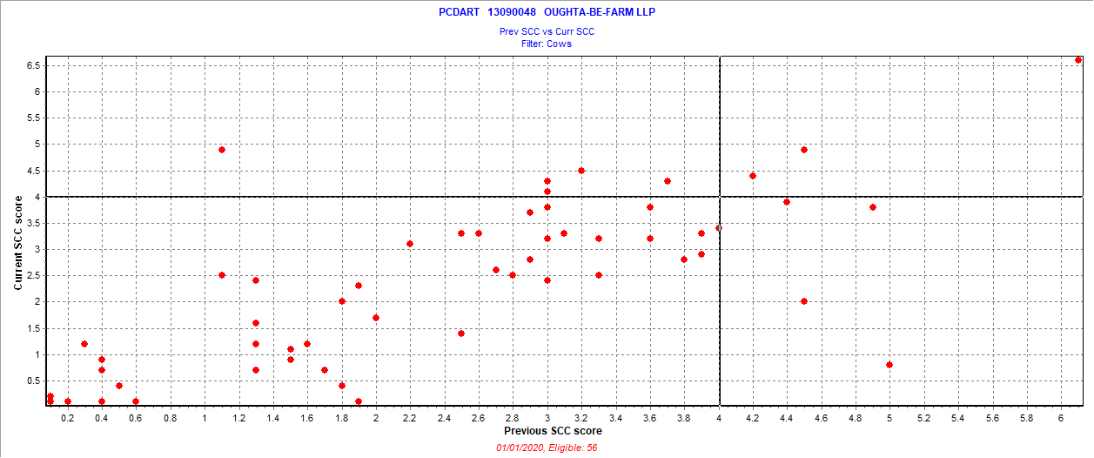

December 21 2019 test date

New = 5 = 8.9%

Chronic = 3 = 5.4%

Cure = 4 = 7.1%

Uninfected = 44 = 78.6%

Also 1 fresh cow SCC > 3.9